LAB REPORT # 04


Submitted by:

Submitted by:

Name | Registration No.
Muhammad Abdullah | FA24-BSE-042
Submitted to: Sir Raheel Ahmed
Course Code: EEE240
Dated: Mar 15 , 2026.

DEPARTMENT OF COMPUTER SCIENCE
COMSATS UNIVERSITY ISLAMABAD,
ISLAMABAD CAMPUS

Boolean Function Implementation using Universal Gates

In-Lab Tasks-Part-1:

Lab-3 task, F(a,b,c,d) = Σm(0,1,2,3,8,10,15)
Expanded SOP:
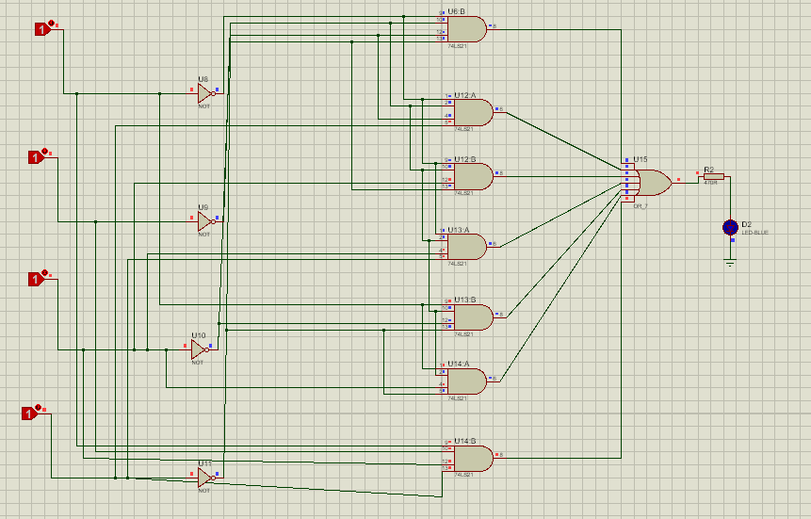
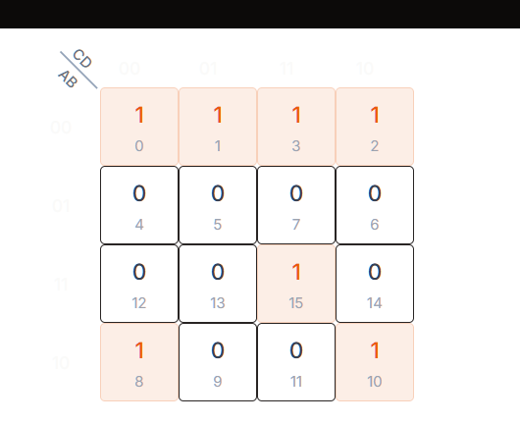
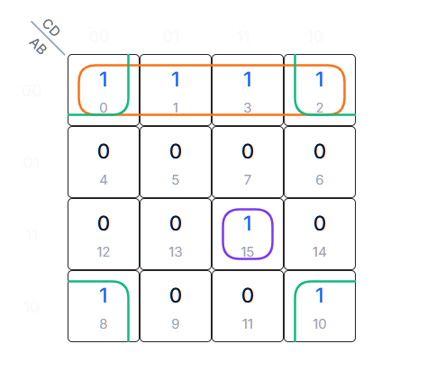

Simplified Boolean Expression
A'B'+ABCD+B'D'
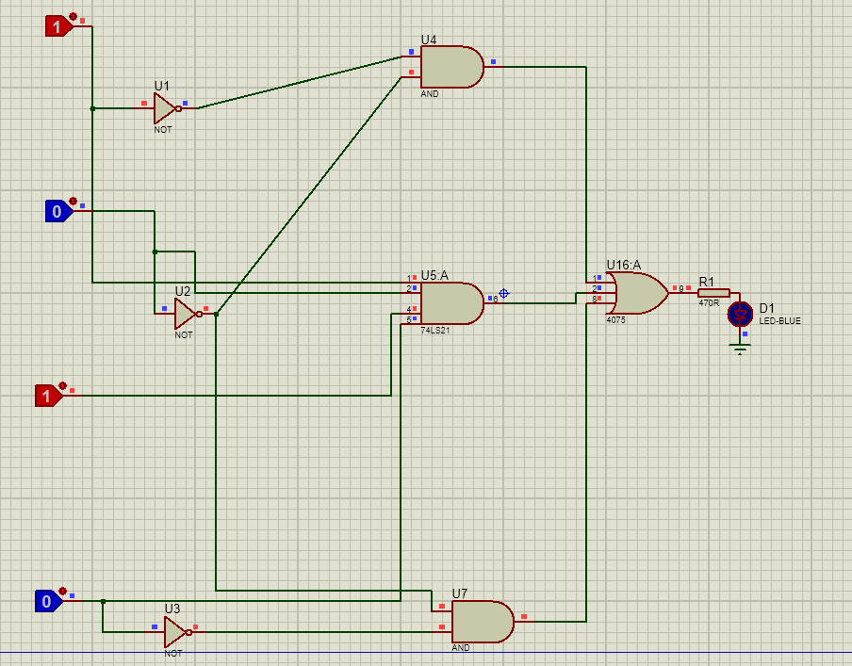
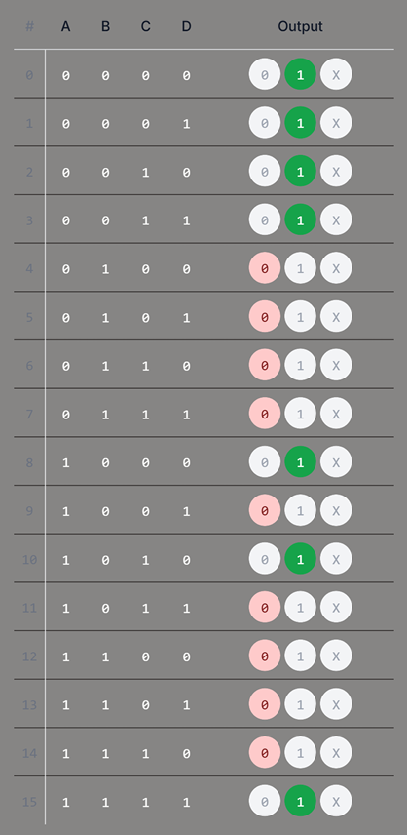

Conclusion
In this lab, the Boolean function F(a, b, c, d) = Σm(0, 1, 2, 3, 8, 10, 15) was implemented using universal logic gates. The experiment illustrated how complex Boolean expressions can be simplified and practically realized using only NAND or NOR gates. By expanding the Sum of Products (SOP) expression and simplifying it to the reduced form A'B' + ABCD + B'D', it became clear how Boolean algebra and minimization techniques help decrease circuit complexity while still preserving the correct logical output.
Overall, the lab strengthened fundamental concepts of digital logic design, including truth tables, minterm representation, Boolean simplification, and universal gate implementation. These concepts are essential for designing efficient and optimized digital circuits.

